Exercise 1-3

Your first SPFx webpart

Objective: Use the tools installed in the second exercise to create a new SharePoint Framework component and test it using the local workbench.

Open a command prompt and change to an empty folder where you want to store the files for the project.

Run the SharePoint Yeoman generator by executing the following command:

yo @microsoft/sharepoint

Use the following to complete the prompt that is displayed (all defaults):

* **What is your solution name?**: HelloWorld
* **Which baseline packages do you want to target for your component(s)?**: SharePoint Online only (latest)
* **Where do you want to place the files?**: Use the current folder
* **Do you want to allow the tenant admin the choice of being able to deploy the solution to all sites immediately without running any feature deployment or adding apps in sites?**: No
* **Will the components in the solution require permissions to access web APIs that are unique and not shared with other components in the tenant?**: No
* **Which type of client-side component to create?**: WebPart
* **What is your Web part name?**: HelloWorld
* **What is your Web part description?**: HelloWorld description
* **Which framework would you like to use?**: No JavaScript framework

After provisioning the folders required for the project, the generator will install all the dependency packages using NPM.

When NPM completes downloading all dependencies, install the developer certificate by executing the following command:

gulp trust-dev-cert

Run the project by executing the following command:

gulp serve

The SharePoint Framework's gulp **serve** task will build the project, start a local web server, and launch a browser open to the SharePoint Workbench.

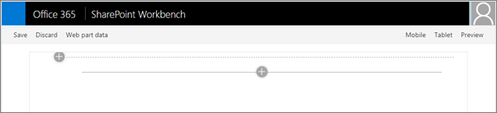

Select the web part icon button to open the list of available web parts.

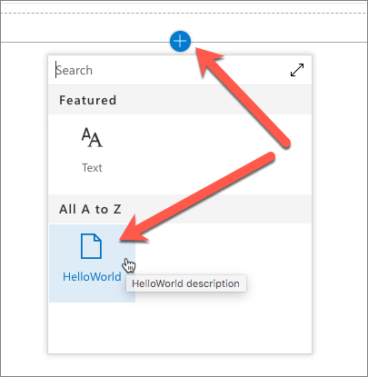

Select the **HelloWorld** web part.

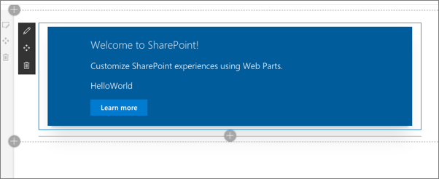

Edit the web part's properties by selecting the pencil (edit) icon in the toolbar to the left of the web part.

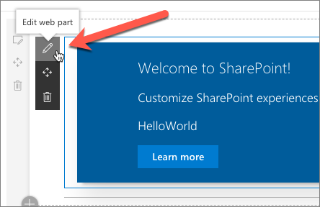

In the property pane that opens, change the value of the **Description Field**. Notice how the web part updates as you make changes to the text.

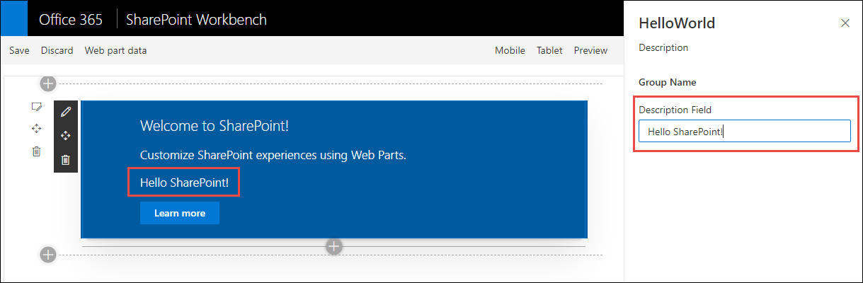

Close the browser and stop the local web server by pressing CTRL+C in the command prompt.

## Summary

In this exercise, you added and interacted with SharePoint Framework-based client-side web parts in a SharePoint Online modern site collection.